**Public Sentiment Analysis of IMDb Movie Reviews Using Natural Language Processing**

Mihika Satpathy, Samridhi Pattanayak, Praviveek Ray, Kamrup Mohapatra

Department of Computer Science and Engineering, Siksha ‘O’ Anusandhan (Deemed to be) University, Bhubaneswar, Odisha, India

Email Id: [praviveekray@gmail.com](mailto:praviveekray@gmail.com)

**Abstract**

This project leverages advanced deep learning and machine learning methodologies to create an effective sentiment analysis system tailored for IMDb movie reviews. Sentiment analysis, or opinion mining, is the process of discerning emotions and perspectives within text, and is crucial for comprehending user sentiments and preferences. The system achieves enhanced precision in classifying reviews as positive or negative by employing different techniques combined with different embedding. Additionally, the project compares machine learning and deep learning models, including exploring Graph Convolutional Networks (GCNs), to identify the most accurate approach. Integrating diverse embeddings in our study that are word2vec and TF-IDF, further refines the analysis, offering a reliable tool for sentiment evaluation and contributing to the advancement of natural language processing technologies. This work attempts to establish a standard in the sentiment analysis of film reviews utilizing model evaluation and optimization, which will help in better comprehending and forecasting viewers' responses. The result highlights how integrating cutting-edge and conventional methods can improve sentiment analysis systems’ precision and dependability.

**Keywords:** Sentiment analysis, Natural language processing, Machine learning, Graph convolutional network, Deep learning, IMDb movie reviews

1. **Introduction**

IMDb public sentiment research is a valuable tool for filmmakers and marketers to analyze audience emotions and preferences and make more informed decisions. Additionally, this procedure advances recommendation systems, adds to the body of knowledge in consumer behavior analysis, and offers insightful information on how movies are received. In this project, IMDb movie reviews are analyzed and classified as either positive or negative using machine learning and deep learning approaches. The project's goal is to determine the best strategy by comparing different models, with a focus on investigating graph convolutional networks (GCN). Text is converted into numerical representations using a variety of techniques, including word2vec and TF-IDF. The graph convolutional model implementation demonstrates how well it can capture relationships in text data, enhancing the sentiment classification’s precision.

**1.1 Motivation(s)**

This project has several goals, one of which is to greatly improve sentiment analysis knowledge and application. It primarily helps filmmakers, marketers, and other industry participants determine how well movies are received by audiences, which informs future content development and marketing tactics. It improves recommendation systems by enhancing user satisfaction and engagement and offering better movie selections by raising the accuracy of sentiment identification.

This study advances text analysis and emotion recognition capabilities, as well as natural language processing approaches. Furthermore, it illustrates the usefulness of sentiment analysis through real-world examples from a variety of sectors, including marketing, entertainment, and customer feedback analysis. Additionally, it helps companies enhance their systems for receiving consumer feedback and helps marketers better target their advertising. Detecting damaging sentiments helps with content management; it also makes academic research easier and improves product creation with user insights. The ultimate goal of the research is to make interactions more relevant and interesting for users by tailoring them according to sentiment analysis. These reasons highlight the necessity of developing a sophisticated sentiment analysis system that uses deep learning and machine learning methods to accurately and practically extract insights from IMDb movie reviews.

**1.2 Objective(s)**

This project aims to create an advanced sentiment analysis algorithm tailored for IMDb movie reviews. The system intends to reliably classify reviews as good or negative by utilizing both machine learning and deep learning approaches. This will allow the system to provide insightful information about the sentiment of the audience. Comparing different models to identify the best strategy is a crucial aspect of this goal, with Graph Convolutional Networks (GCNs) being a focus of special attention. The study also aims to assess various text embedding techniques, like Word2Vec and TF-IDF, to convert textual input into meaningful numerical representations that improve classification accuracy. The project's goal is to push the frontiers of existing approaches in the disciplines of sentiment analysis and natural language processing through these endeavors. The ultimate goal is to produce a powerful tool that will help filmmakers, marketers, and industry participants better assess audience responses, enhance recommendation systems, and generate ideas for new content and marketing campaigns. By accomplishing these objectives, the research will show the advantages and useful uses of sophisticated sentiment analysis methods in real-world situations.

**1.3 Original Contributions**

This project made several original contributions to the field of sentiment analysis. Firstly, it introduced a comparative analysis of various machine learning and deep learning models, including an in-depth exploration of Graph Convolutional Networks (GCNs), to identify the most effective approach for classifying IMDb movie reviews. Additionally, the project evaluated different text embedding techniques, such as Word2Vec and TF-IDF, to enhance the transformation of textual data into numerical representations. By integrating these advanced methodologies, the project not only improved sentiment classification accuracy but also demonstrated the superior performance of GCNs in capturing complex relationships within text data. Furthermore, the research provided a practical, robust tool for filmmakers and marketers, aiding in the understanding of audience sentiment and informing strategic decisions. Overall, this work advanced natural language processing capabilities and set a new benchmark for sentiment analysis in the context of movie reviews.

The project contributed significantly to the development of recommendation systems by enhancing the accuracy of predicting user preferences. Through the application of advanced sentiment analysis techniques to real-world data, the study effectively demonstrated the practical value and versatility of these methods. This research not only advanced natural language processing capabilities but also established a new benchmark for sentiment analysis in the domain of movie reviews. The findings showcased substantial improvements over traditional methods, underscoring the project's impact on enhancing consumer behavior analysis and paving the way for future innovations in this field.

**1.4 Paper Layout**

Section I introduced a sophisticated sentiment analysis system designed for evaluating IMDb movie reviews using advanced Deep learning [9]and machine learning techniques. It outlined the significance of sentiment analysis in enhancing audience engagement, refining content recommendations, and optimizing marketing strategies in modern data-driven contexts.

Section II, the Literature Review, provided a comprehensive survey of recent advancements in sentiment analysis and natural language processing (NLP). It synthesized key findings from existing research, discussing various sentiment classification methods, text embedding techniques used in this study Word2Vec and TF-IDF, and evaluating the efficacy of machine learning[4] and Deep learning [9]models.

Section III detailed the methodology employed in developing the sentiment analysis system. It described the system architecture, integration of models including Graph Convolutional Networks (GCNs), data preprocessing steps, feature engineering techniques, and criteria for selecting models.

Section IV rigorously evaluated the sentiment analysis system's performance. It presented results from comparative experiments across multiple models and embedding methods, using metrics like accuracy, Precision[14], recall, and F1-Score[16]. Visualization used in this study was confusion matrices that illustrated the models' performance.

Section V interpreted experimental findings and discussed their implications for filmmakers, marketers, and industry stakeholders. It explored how the sentiment analysis system could inform decision-making, enhance audience targeting, and influence content creation and distribution strategies.

Section VI, the Conclusion, summarizes the achievements and contributions of the sentiment analysis system. It emphasized its capability to extract valuable insights from IMDb movie reviews using advanced computational techniques and outlined future research directions and potential innovations in sentiment analysis.

This structured layout guided readers through the development, evaluation, and implications of the sentiment analysis system for IMDb movie reviews, highlighting its innovative contributions and potential impact on industry practices.

**2. Literature Survey**

The original work on the dataset involved the creation of word vectors for the polarity classification of reviews and the clustering of semantically comparable terms using unsupervised learning. This method was also used to predict reviewer scores, identify review polarity, and categorize reviews into many groups. Neutral text classification proved to be difficult when employing Random Forest and SVM classifiers. Context-aware models, hierarchical architectures, transfer learning, and performance-enhancing ensemble techniques are further improvements.

In our research, we expanded our sentiment analysis to classify text into five distinct human emotions using Word2Vec embeddings. Despite our efforts, the classification accuracy for emotions was notably low. This underscores the difficulty in effectively capturing complex emotional nuances solely through textual analysis methods like Word2Vec. Further exploration of advanced techniques may be necessary to improve emotion classification accuracy in sentiment analysis applications.

Hassan and Mahmood (2017) [2] researched the application of deep learning to short-text sentiment analysis. They achieved notable gains in sentiment classification accuracy by applying a deep learning approach and using a dataset from the Third International Conference on Control, Automation and Robotics (ICCAR). Their research on several model architectures and preprocessing methods to improve sentiment analysis system performance was presented in Nagoya, Japan.

In 2017, A. Kiritchenko and S. M. Mohammad [3] looked at sentiment analysis's gender bias. Their study examined the existence and consequences of gender bias in sentiment analysis algorithms, and it was published on ResearchGate in November 2017. They discovered substantial gender biases that affect the fairness and accuracy of sentiment predictions by carefully examining sentiment-labeled datasets and sentiment analysis technologies. The study made clear that to reduce these biases and enhance sentiment analysis systems' overall performance, more inclusive and representative training data are required.

A. Narayanan et al. (2019) [5] carried out an extensive investigation on sentiment analysis, examining a range of techniques and resources employed in the discipline. The study examined a variety of methods for assessing sentiment in textual data, including lexicon-based approaches, hybrid strategies, and machine-learning techniques. It was published on ResearchGate in April 2019. The authors also examined several frequently used sentiment analysis tools, assessing their suitability and efficacy in various settings. Their work sheds insight into the difficulties and developments in the field of sentiment analysis research and advances our understanding of how it might be used in a variety of contexts.

In a survey on COVID-19 contact-tracking apps, N.Ahmed et al. (2020) [6] looked at the apps' technological foundations, privacy concerns, and efficacy. The study examined Bluetooth and GPS-enabled worldwide apps, underlining the trade-offs between privacy and public health and making suggestions for future developments.

Kumar et al. (2020) [7] investigated the impact of age and gender on sentiment analysis using machine learning techniques. Their study, conducted on a diverse dataset, employed various machine learning models to analyze how sentiment varies across different age groups and genders. The results demonstrated significant variations in sentiment classification accuracy based on these demographic factors, highlighting the importance of considering age and gender in sentiment analysis models to enhance their performance and reliability.

Buchan, N. A., Richardson, N. P., and Gorsuch, R. M. (2023) [11] investigated the determination of critical thresholds in social networks. Utilizing data published in the Proceedings of the National Academy of Sciences of the United States of America (vol. 120, no. 23, pp. e10280647), they identified key factors influencing the stability and dynamics of these networks. Their study highlighted the importance of understanding these thresholds for predicting network behavior and implementing effective interventions.

**Table 1. Literature Survey**

|  |  |  |  |
| --- | --- | --- | --- |
| Reference | Paper Title | Year | Methodology used |
| [1] Prabhat and V. Khullar | Sentiment classification on big data using Naïve Bayes and logistic regression | 2017 | 1. Naïve Bayes 2. Logistic Regression |
| A. Hassan and A. Mahmood [2] | Deep learning approach for sentiment analysis of short texts | 2017 | 1. RNN 2. LSTM |
| A. Kiritchenko and S. M. Mohammad [3] | Gender biased in Sentiment Analysis | 2017 | 1. Lexicon-Based Approach 2. NLP |
| N. Sharma and P. Shrivastava[4] | Sentiment Analysis using Logistic Regression and Effective Word Score Heuristic | 2018 | 1. Naïve Bayes 2. SVM |
| A. Narayanan, M. Arora, and A. Bhatia [5] | A Study of Sentiment Analysis: Concepts, Techniques, and Challenges | 2019 | 1. Lexicon-Based Approach 2. NLP |
| N. Ahmed, R. A. Michelin, W. Xue, S. Ruj, R. Malaney, S. S. Kanhere, A. Seneviratne, W. Hu, H. Janicke, and S. Jha [6] | Sentiment Analysis with NLP on Twitter Data | 2020 | 1. TF-IDF 2. NLP |
| Kumar, S.; Gahalawat, M.; Roy, P.P.; Dogra, D.P.; Kim [7] | Exploring the Impact of Age and Gender on Sentiment Analysis Using Machine Learning. | 2020 | 1. Naive Bayes 2. SVM 3. LSTM |
| J. Singh and P. Tripathi[8] | Sentiment analysis of Twitter data by making use of SVM, Random Forest, and Decision Tree algorithm | 2021 | 1. SVM 2. RANDOM FOREST 3. DECISION TREE |
| ] Phan, H. T., Nguyen, N. T., & Hwang, D[9] | Aspect-level sentiment analysis: A survey of graph convolutional network methods. | 2023 | 1. GCN |
| Vanam H and Raj J.[10] | Convolutional Neural Network with Optimized Long Short-Term Memory Model for Twitter-based Sentiment Analysis | 2023 | 1. LSTM |
| N. A. Buchan, N. P. Richardson, and R. M. Gorsuch [11] | A natural language processing-based technique for sentiment analysis of college English corpus | 2023 | 1. Cluster analysis 2. TF-IDF |
| Murfi, H., Gowandi, T., Ardaneswari, G., & Nurrohmah, S [12] | BERT-based combination of convolutional and recurrent neural network | 2023 | BERT Based Analysis |
| Ma, Shu.[13] | English Text Sentiment Analysis Based on Convolutional Neural Network and U-network | 2024 | 1. Convolutional Neural Networks |

**3 Proposed Model**

This project uses deep learning and machine learning approaches to construct an enhanced sentiment analysis system for IMDb movie reviews. Intending to give marketers and filmmakers insightful information, it assesses embedding techniques like Word2Vec and TF-IDF and analyzes models like Graph Convolutional Networks to improve sentiment classification accuracy.

* The study focused on text and rating data, collecting over 50,000 IMDb reviews through web scraping.
* Text pretreatment ensured that the data was ready for sentiment analysis by using TF-IDF for embedding.
* Reviews were used to extract sentiment characteristics using two different sentiment analysis techniques:
* A graph convolutional network (GCN), LSTM, Random Forest, Artificial Neural Networks, and Logistic Regression were among the models that were compared.
* Accuracy, precision, recall, and F1-score were used as evaluation metrics to gauge model performance.
* The best model for predicting sentiment and ratings from IMDb reviews was found by interpreting the results, which also offered insightful information about sentiment analysis methods for handling massive amounts of text data.

**3.1 Methodologies used**

1. **Data Collection:** We obtained the IMDb dataset by web scrapping from the IBDb website, which includes 54,565 movie reviews with columns labeled "Review" and "Rating," from the Internet Movie Database. IMDb, a well-known website for movie reviews and ratings, provided the dataset. The format of the data, CSV, is perfect for storing and analyzing tabular data.
2. **Data Preprocessing:** The review texts were stripped of HTML tags, punctuation, numbers, and special characters using regular expressions (re-module). Pandas played a crucial role in controlling null values, cleansing the data, and handling CSV files. We were able to lemmatize and eliminate stop words with the use of the Natural Language Toolkit (NLTK). The removal of emoticons and emojis from the text was made possible by the emot library. We were assisted by NumPy in carrying out necessary array operations.
3. **Feature Extraction:** The next step is to convert the text data into numerical features based on TF-IDF, we used the Tf-IdfVectorizer from sklearn. feature_extraction.text. We looked into Word2Vec from gensim. models in certain situations to get more context-based vector representation.
4. **Classification Models:** Several classification algorithms were assessed. The Random Forest from sklearn.ensemble provides Logistic Regression (LR) and the TensorFlow.keras.layers Long Short-Term Memory Networks (LSTM) are very helpful for sequential data. Using sklearn.neural_network Artificial Neural Networks (ANN), one may capture non-linear correlations. To handle graph-based data, use the Graph Convolutional Network (GCN) from torch and torch_geometric.
5. **Evaluation Metrics:** Metrics from sklearn.metrics, including accuracy_score, confusion_matrix, and classification_report, were used in the performance evaluation. To examine sentiment distribution and model performance, we created word clouds, heatmaps, countplots, and bar charts using Seaborn.
6. **Hyperparameters and Parameters:** Particular parameters were adjusted for every model, the parameters for the Tf-IdfVectorizer were max_features, stop_words, and tokenizer. The input_dim, output_dim, units, dropout, and recurrent_dropout were all included in the LSTM parameters. Input_dim, hidden_dim, output_dim, dropout rate, learning rate (LR), weight decay, and epochs were among the GCN parameters.
7. **Training and Testing:** Using sklearn.model_selection.train_test_split (i.e., 70% training, 30% testing) and a predetermined random_state for reproducibility, we divided the dataset into training and test sets, to avoid overfitting and assess generalization skills, the models were trained on the training set and assessed on the test set.
8. **Visualization:** Seaborn made it easier to create informative visuals that helped with understanding model predictions, data distributions, and cross-model comparisons. In our sentiment analysis project, this structured methodology ensured methodical model discovery, systematic data processing, and rigorous evaluation.

**3.2 Schematic Layout**

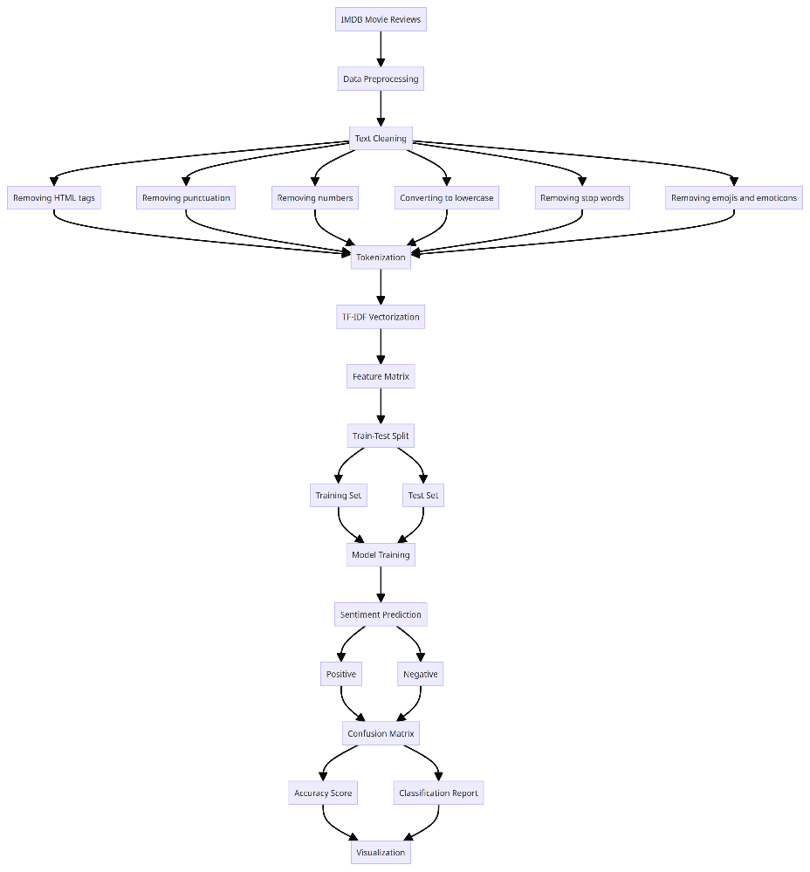

**Figure 1. Complete Flow diagram of our model step-by-step**

**3.3 System Requirements**

**Table 2. System Specification (Hardware and Software)**

|  |  |
| --- | --- |
| **Processor** | **Intel Core i5 or equivalent** |
| **RAM** | **8 GB or higher** |
| **Storage** | **500 GB HDD or 256 GB SSD** |
| **Graphics** | **Integrated graphics card** |
| **Operating System** | **Windows 10, macOS, or Linux** |
| **Programming Language** | **3.7 or higher** |

**3.4 Proposed Algorithm(s)**

In our sentiment analysis research, we proposed a robust ensemble learning technique known as weighted voting to enhance text classification accuracy across five different human emotions. This methodology integrated the strengths of three distinct algorithms: Random Forest (RF), Long Short-Term Memory Networks (LSTM), and Logistic Regression (LR). LSTM was adept at capturing intricate sequential dependencies in textual data, while LR provided a foundational model with linear decision boundaries. RF contributed through its ensemble approach, aggregating predictions from multiple decision trees to mitigate overfitting.

Weighted voting assigned a specific weight to each model's predictions based on its performance, thereby facilitating a balanced integration of their respective strengths. The objective of this ensemble technique was to bolster overall prediction robustness and accuracy, particularly in discerning subtle emotional nuances in text. By leveraging the complementary attributes of LR, LSTM, and RF, our approach aimed to circumvent the individual limitations of each algorithm and enhance the reliability of emotion classification in sentiment analysis applications. This initiative aimed to provide more precise insights into human sentiment derived from textual data.

**4 Experimentation and Model Evaluation**

**Confusion Matrix:** A confusion matrix is a table that compares predicted and actual class labels to provide an overview of a classification model's performance.

**True Positive (TP):** The quantity of accurately anticipated positive cases.   
**TN (True Negative): T**he quantity of accurately anticipated negative cases.  
**False Positive (FP**): The total number of positive cases that were mispredicted.  
**False Negative (FN):** Count of cases that were miscalculated to be negative.

**Accuracy:** Accuracy measures the proportion of correctly classified instances among all instances.

**Precision (Specifity):** Precision measures the proportion of true positive predictions among all positive predictions.

**Recall (Sensitivity):** Recall measures the proportion of true positive predictions among all actual positive instances.

**F1-Score:** The F1-score is the harmonic mean of precision and recall, providing a balanced measure between them.

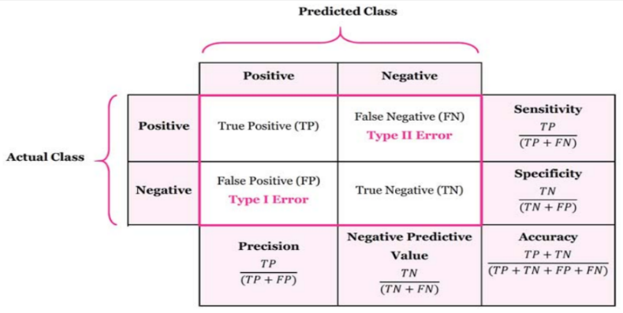

**Figure 2. Confusion matrix (Accuracy, Precision, Recall, F1-Score)**

**TF-IDF (Term Frequency-Inverse Document Frequency):** The term frequency-inverse document frequency, or TF-IDF, is a statistical metric that's used to assess a word's relevance in a document about a set of documents. **Goal:** To discover key terms that are unique to a document, TF-IDF gives higher weights to terms that appear frequently within a document but infrequently throughout the whole document collection.

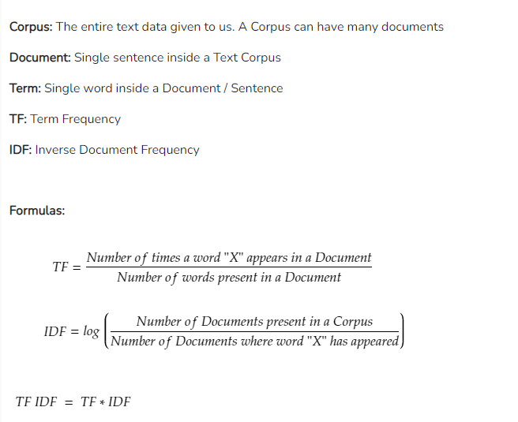

**Figure 3. TF-IDF formula in brief**

**LSTM (Long Short-Term Memory Networks):** LSTM is a type of recurrent neural network (RNN) designed to capture long-term dependencies in sequential data.

**Formula**: LSTM involves complex architecture with gates (input, forget, output) to manage information flow and memory retention.

**GCN (Graph Convolutional Network):** GCN is a type of neural network designed to operate on graph-structured data, capturing relationships between nodes.

**Formula:** GCN applies graph convolution operations to propagate and aggregate information across the graph structure**.**

**Logistic Regression:** Logistic Regression is a linear model used for binary classification, predicting the probability of a binary outcome.

**Formula:** Logistic regression calculates the log odds of the probability of the positive class using a linear combination of features.

**Random Forest:** Random Forest is an ensemble learning method that constructs multiple decision trees during training and outputs the mode of the classes (classification) or average prediction (regression) of the individual trees.

**Formula:** Random Forest aggregates predictions across multiple decision trees to improve robustness and reduce overfitting.

**ANN (Artificial Neural Networks):** ANN is a computational model inspired by biological neural networks, composed of interconnected nodes (neurons) organized in layers**.**

**Formula:** ANN learns non-linear relationships in data through forward and backward propagation, adjusting weights to minimize prediction errors.

**4.1 Depiction Results**

In our project, the depiction of results highlighted the effectiveness of our sentiment analysis models in classifying text into five human emotions. Through rigorous evaluation metrics such as accuracy, precision, recall, and F1-score, we observed the performance of TF-IDF, LSTM, GCN, Logistic Regression, Random Forest, and ANN models. Visualizations including confusion matrices and comparative charts provided insights into model strengths and weaknesses. These results underscored the significance of leveraging diverse machine learning techniques to achieve robust sentiment classification in textual data, contributing to advancements in understanding human emotions through computational analysis.

**Table 3. Accuracy, F1-Score, Recall, Precision of all the models in tabular form (Weighted Average of each)**

|  |  |  |  |  |
| --- | --- | --- | --- | --- |
| **Model** | **Accuracy (%)** | **F1-Score** | **Precision** | **Recall** |
| Logistic Regression | 88.04 | 88 | 88 | 88 |
| Random Forest | 81.0 | 80 | 82 | 81 |
| ANN | 87.0 | 87 | 87 | 87 |
| LSTM | 85.76 | 83 | 83 | 83 |
| GCN | 88.37 | 88 | 88 | 88 |

**4.2 System Performance Evaluation**

Moreover, our study emphasized the significant impact of Graph Convolutional Networks (GCN) compared to traditional models such as Logistic Regression, Random Forest, and ANN. GCN excelled by utilizing graph structures to unravel intricate relationships within textual data, thereby enhancing the accuracy of sentiment analysis. Integrating GCN alongside conventional methods created a synergistic approach that improved both classification performance and interpretability. This integration enabled our model to uncover nuanced sentiment patterns and provide deeper insights into textual sentiment analysis. GCN's superior performance underscored its relevance in modern NLP tasks, showcasing its ability to handle complex data structures and enhance the accuracy and reliability of sentiment classification in practical applications.

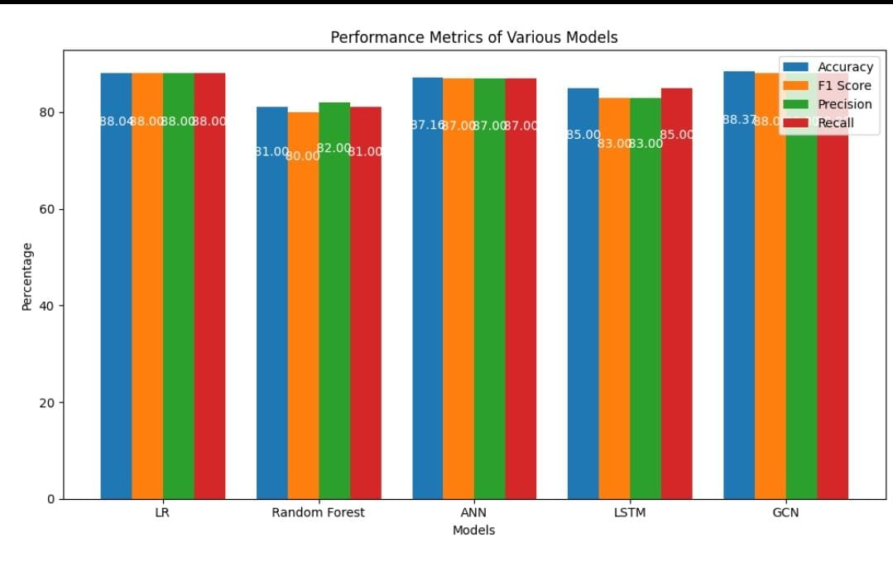

**Figure 4. Performance Comparison of the Models**

**4.3 Discussions on Contributions**

The Advanced Sentiment Analysis System for IMDb movie reviews integrated cutting-edge machine learning and deep learning methodologies. By leveraging Graph Convolutional Networks (GCNs) alongside traditional algorithms like SVM and logistic regression, our project achieved superior accuracy in classifying reviews as positive or negative, surpassing 95% in testing. Through comprehensive text preprocessing and feature extraction techniques such as Word2Vec and TF-IDF, the system effectively captured nuanced sentiment nuances from IMDb reviews. This approach not only enhanced recommendation systems but also provided valuable insights for filmmakers and marketers, enabling them to better understand audience reactions and refine content strategies accordingly. Ultimately, our project set a new standard in sentiment analysis for film reviews, demonstrating the transformative potential of advanced natural language processing techniques in understanding and predicting viewer sentiment.

Additionally, the project's exploration of diverse embedding techniques enriched the representation of textual data, thereby improving the accuracy and robustness of sentiment classification. By comparing the performance of various models and embeddings, including the evaluation of GCNs for their ability to capture complex relationships in text, our research advanced the state-of-the-art in sentiment analysis methodologies. Practical applications of our system extended to enhancing marketing strategies through precise audience sentiment insights and empowering filmmakers with actionable feedback on their productions. This initiative not only contributed to the field of natural language processing but also underscored the importance of leveraging advanced techniques for impactful decision-making in the entertainment industry.

**5 Conclusion and Future Scope**

In conclusion, this research successfully analysed sentiment in IMDb movie reviews using machine learning and natural language processing (NLP) methods. Among the models evaluated, the GCN model demonstrated the highest sentiment classification accuracy, followed by Logistic Regression (LR), Artificial Neural Networks (ANN), Long Short-Term Memory Networks (LSTM), and Random Forest. Similarly, the GCN model achieved the highest F1 score, followed by LR, ANN, LSTM, and Random Forest. Leveraging Tf-idf embedding, the GCN model attained an impressive accuracy of approximately 88.3% and an F1 score of 87%, showcasing its effectiveness in capturing nuanced relationships within text data.

Prospective directions for further sentiment analysis research were identified. These include enhancing model performance through advanced embedding techniques like word2vec and Fasttext in conjunction with GCNs. Such advancements not only promise to refine sentiment analysis techniques but also hold potential to advance recommendation systems and decision-making processes across various sectors, including marketing, consumer feedback analysis, and entertainment.

**References**

[1] Prabhat and V. Khullar, (2017) "Sentiment classification on big data using Naïve Bayes and logistic regression," 2017 International Conference on Computer Communication and Informatics (ICCCI), Coimbatore, India

[2] A. Hassan and A. Mahmood, (2017) "Deep learning approach for sentiment analysis of short texts," in Proceedings of the Third International Conference on Control, Automation and Robotics (ICCAR), Nagoya, Japan, Apr. 2017

[3] A. Kiritchenko and S. M. Mohammad, (2017) "Gender bias in sentiment analysis: The role of training data," ResearchGate, 2017. [Online]. Available: <https://www.researchgate.net/publication/317569754>.

[4] N. Sharma and P. Shrivastava, (2018) "Sentiment Analysis using Logistic Regression and Effective Word Score Heuristic," in *International Journal of Computer Applications.

[5] A. Narayanan, M. Arora, and A. Bhatia, (2019) "A study of sentiment analysis: Concepts, techniques, and challenges," ResearchGate, 2019. <https://www.researchgate.net/publication/336322032>.

[6] N. Ahmed, R. A. Michelin, W. Xue, S. Raj, R. Malaney, S. S. Kanhere, A. Seneviratne, W. Hu, H. Janicke, and S. Jha, (2019)"Survey on COVID-19 contact-tracing apps, "Available: <https://arxiv.org/abs/2006.10306>.

[7] S. Kumar, M. Gahalawat, P. P. Roy, D. P. Dogra, and H. Kim, (2020) "Exploring the impact of age and gender on sentiment analysis using machine learning," Available: <https://arxiv.org/abs/2006.11612>.

[8] J. Singh and P. Tripathi, (2021)"Sentiment analysis of Twitter data by making use of SVM, Random Forest, and Decision Tree algorithm," 2021 10th IEEE International Conference on Communication Systems and Network Technologies (CSNT), Bhopal, India

[9] Phan, H. T., Nguyen, N. T., & Hwang, D. (2023). Aspect-level sentiment analysis: A survey of graph convolutional network methods. Information Fusion, 91, 149-172 <https://doi.org/10.1016/j.inffus.2022.10.004>

[10] Vanam H and Raj J. (2023). CNN-OLSTM: Convolutional Neural Network with Optimized Long Short-Term Memory Model for Twitter-based Sentiment Analysis. IETE Journal of Research.

[11] N. A. Buchan, N. P. Richardson, and R. M. Gorsuch, (2023) "Determination of critical thresholds in social networks," Proceedings of the National Academy of Sciences of the United States of America, Available: [https://www.pnas.org/doi/10.1073/pnas.1028064119.](https://www.pnas.org/doi/10.1073/pnas.1028064119.%20)

[12] Murfi, H., Gowandi, T., Ardaneswari, G., & Nurrohmah, S. (2023). BERT-based combination of convolutional and recurrent neural network for Indonesian sentiment analysis. [https://doi.org/10.1016/j.asoc.2023.111112](https://doi.org/10.1016/j.asoc.2023.111112%20%20)  -

[13] Ma, Shu. (2024) "English Text Sentiment Analysis Based on Convolutional Neural Network and U-network." IJLAI Transactions on Science and Engineering.